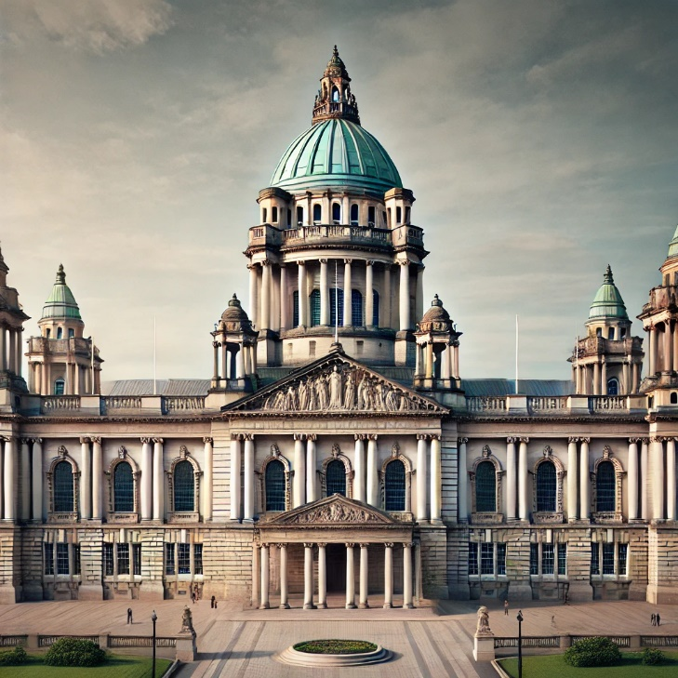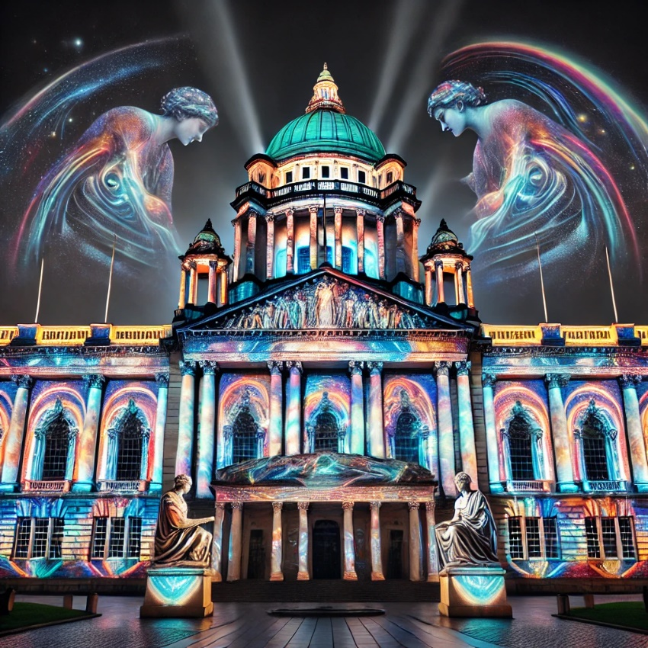AI Images Generated